Quiz #2 : Unit 3 & Unit 4
By: Professor Philip Anthony Lujan
Date: August 29th, 2020
Designed for level: A1/A2
1.Complete with have or has
2. Look the picture and describe the members of the family
He to do his homework
I vacations next month
They kids
you money?
She a headache

3. Scramble the next sentences
4. Look the picture and write for sentences using ( make ,take, do, have)
Work I with my family
Every do Monday they Yoga
Prepare breakfast kids I for the my
at the you park run at
dogs play with the we

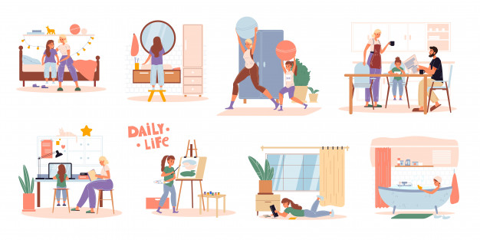
6. Look the example and follow it for the next sentences

Example: this is the toy of Michael: this is Michael´s toy
The house of my mom:
The homework of my brother:
The kids of my uncle:
This is the car of my dad:
https://www.youtube.com/watch?v=TuPnPvMQ1YU
7. Watch the next video and answer
a. What do you do in free time?
b. Which activities the people said they do?
c. describes the place and environment of the recording video and survey results

5. Complete with the question or answer the questions

What do you do on weekends?
? I am in the house
Who are you with now?
I am fine, Thank you
Do you do exercise?

