Quiz #1 : Unit 1 & Unit 2
By: Professor Philip Anthony Lujan
Date: August 27th, 2020
Designed for level: A1/A2

1.Complete the sentence
a. Answer the next questions accordingly

What is your name?
How old are you?
Are you a student?
What are your hobbies? __________________

They Happy
I a boy
She Colombian
He in love
We sleepy
You with her

2. Choose the correct Demonstrative Pronoun for each image ( this, that , these ,those)

3. Describe the woman using adjectives and remember the correct order of the adjectives.
4.Complete the list with the correct country or nationality
Brazil
Canadian
Ecuador
Finnish
Italy
Spanish
United Kingdom
Japanese
Ireland
Peruvian
Colombia

6.Which personal belongings do you see in the picture? named them
5.Whose this? My/ her / his /our
This is Mariia
This is book
This is Carlos
This is cat
This is Amanda
This is husband
This is Carlos and Maria
This is House
This is me
This is computer

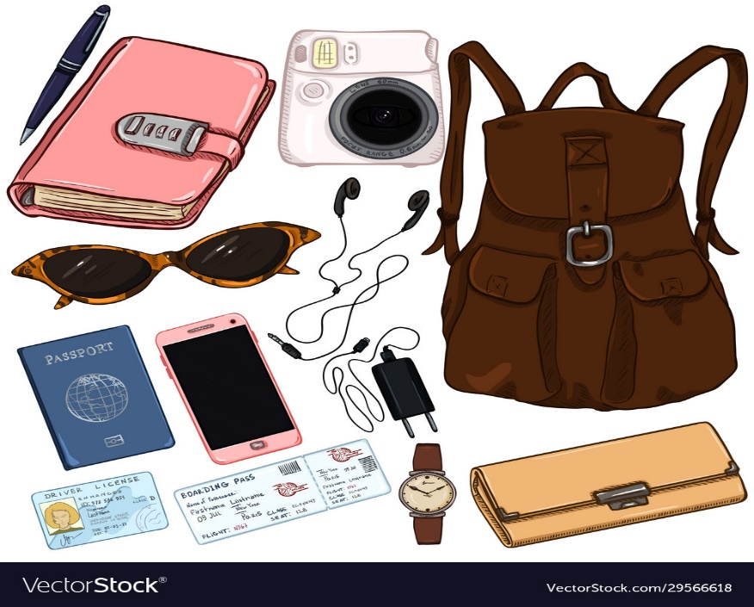
Agent: Good afternoon! Where are you flying to today?
Alex: Colombia
Agent: May I have your passport, please?
Alex: Here you go.
Agent: Are you checking any bags?
Alex: Just this one.
Agent: OK, please place your bag on the scale.
Alex: I have a stopover in Panama – do I need to pick up my luggage there?
Agent: No, it’ll go straight through to Colombia. Here are your boarding passes – your flight leaves from gate 15A and it’ll begin boarding at 3:20. Your seat number is 26E.
Alex: Thanks.

https://www.youtube.com/watch?v=imAQhP9JLN4

7.Watch the video and pay attention to the details
7.Read the dialogue and answer accordingly

8. Adjectives
Directions: Look at the picture and select the correct Adective
Clark Kent and Superman
Clark Kent is _________. Clark Kent has __________.
Superman is _________. Superman is ___________.
I like Superman because he is __________.

Dr. Jekyll and Mr. Hyde
Dr. Jekyll is __________. Dr. Jekyll has __________.
Mr Hyde is __________. Mr. Hyde has __________.
I do not like Mr. Hyde because he is ___________.

9. Writing Section
Directions: Choose a topic and write 5 sentences about the topic. Remember to use new vocabulary you have learned. Good luck
___________________________________________________________________________________________________________________________________________________________________________________________________________________________________________________________________________________________________________________________________________________________________________________________________________________________________________________________________________________________________________________________________________________________

9. Speaking
Tell me about what you did last year. Use as many adjectives, verbs in past simple, and nouns you have learned! Good luck
___________________________________________________________________________________________________________________________________________________________________________________________________________________________________________________________________________________________________________________________________________________________________________________________________________________________________________________________________________________________________________________________________________________________

